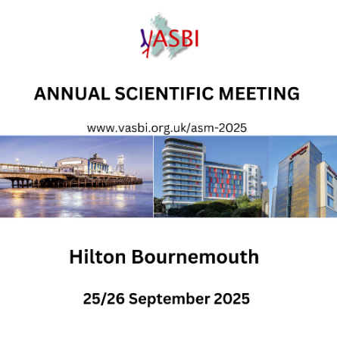 | VASBI STAND STAFF BOOKING FORM  TO BE RETURNED BY 1/9/25 via info@vasbi.org.uk  Accommodation is not included in the sponsorship package.  Bedroom rates have been negotiated at the host venue the Hilton Bournemouth and the Hampton Hotel next door. See rates here: https://www.vasbi.org.uk/asm-2025/hotels/  Allowances per package are below:  Gold x 3 for the Conference and dinner  Silver x 2 for the Conference and dinner  Bronze x 1 for the Conference and dinner  If you wish to book additional sponsor places it is £500 per day

Name | Job Title | Company | Email | Event Days  25 & 26/9/25  (if just one day please specify) | Dinner at the Pier 25/9/25 | Dietary or access requirements or NOTES

